Tarea Terminales – Leonardo Madrigal Sanchez
Ejercicio #1
Comando:
C:\Users\leona\Documents>cd Tarea_Terminales

C:\Users\leona\Documents\Tarea_Terminales>mkdir Empleado1

C:\Users\leona\Documents\Tarea_Terminales>mkdir Empleado2

C:\Users\leona\Documents\Tarea_Terminales>mkdir Empleado3

C:\Users\leona\Documents\Tarea_Terminales>dir
Volume in drive C is Windows-SSD
Volume Serial Number is 10AC-3687

Directory of C:\Users\leona\Documents\Tarea_Terminales

07/04/2026 12:19 PM <DIR> .
07/04/2026 12:18 PM <DIR> ..
07/04/2026 12:18 PM <DIR> Empleado1
07/04/2026 12:18 PM <DIR> Empleado2
07/04/2026 12:19 PM <DIR> Empleado3
0 File(s) 0 bytes
5 Dir(s) 23,516,303,360 bytes free

C:\Users\leona\Documents\Tarea_Terminales>
Imagen:
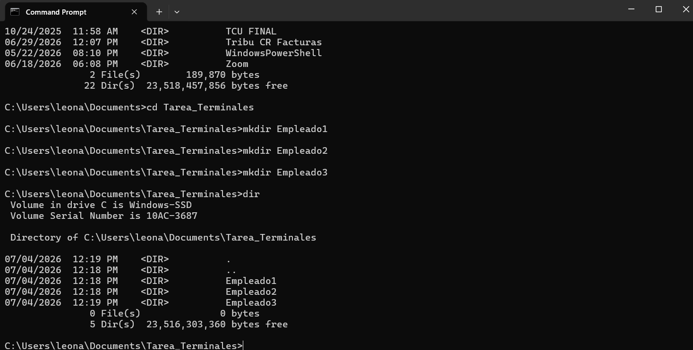
Ejercicio #2:
Comando:
C:\Users\leona\Documents\Tarea_Terminales\Empleado1>echo > bienvenida1.txt

C:\Users\leona\Documents\Tarea_Terminales\Empleado1>dir
Volume in drive C is Windows-SSD
Volume Serial Number is 10AC-3687

Directory of C:\Users\leona\Documents\Tarea_Terminales\Empleado1

07/04/2026 12:24 PM <DIR> .
07/04/2026 12:19 PM <DIR> ..
07/04/2026 12:24 PM 13 bienvenida1.txt
1 File(s) 13 bytes
2 Dir(s) 23,353,622,528 bytes free
Imagen:
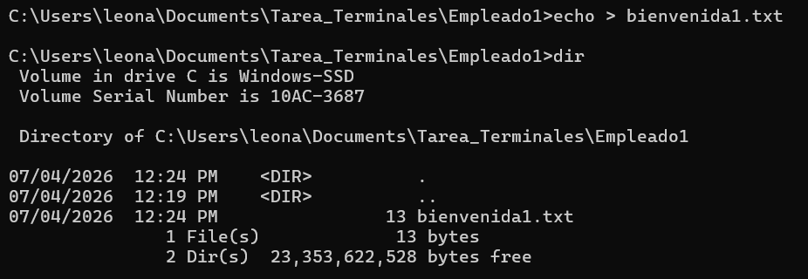
Comando:
C:\Users\leona\Documents\Tarea_Terminales> cd Empleado2

C:\Users\leona\Documents\Tarea_Terminales\Empleado2>echo > bienvenida2.txt

C:\Users\leona\Documents\Tarea_Terminales\Empleado2>dir
Volume in drive C is Windows-SSD
Volume Serial Number is 10AC-3687

Directory of C:\Users\leona\Documents\Tarea_Terminales\Empleado2

07/04/2026 12:26 PM <DIR> .
07/04/2026 12:19 PM <DIR> ..
07/04/2026 12:26 PM 13 bienvenida2.txt
1 File(s) 13 bytes
2 Dir(s) 22,582,398,976 bytes free
Imagen:
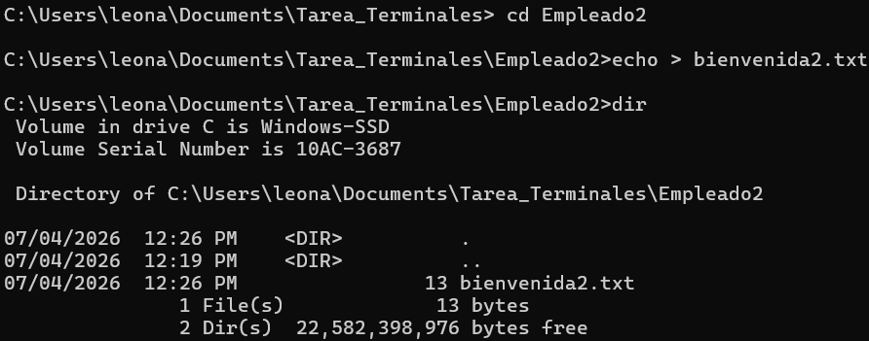
Comando:
Imagen:
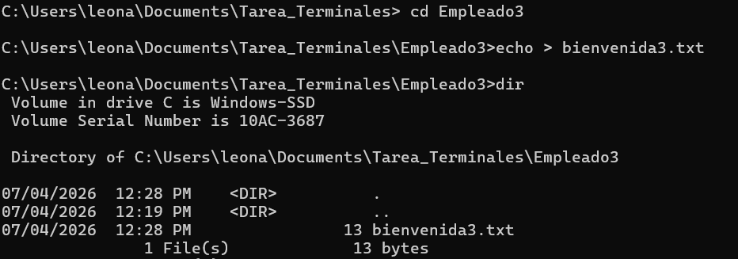
Ejercicio #3:
Comando:
C:\Users\leona>move "C:\Users\leona\Documents\Tarea_Terminales\Empleado1" "C:\Users\leona\OneDrive\Escritorio\Empleados\"
1 dir(s) moved.

C:\Users\leona>move "C:\Users\leona\Documents\Tarea_Terminales\Empleado2" "C:\Users\leona\OneDrive\Escritorio\Empleados\"
1 dir(s) moved.

C:\Users\leona>move "C:\Users\leona\Documents\Tarea_Terminales\Empleado3" "C:\Users\leona\OneDrive\Escritorio\Empleados\"
1 dir(s) moved.

C:\Users\leona>cd C:\Users\leona\OneDrive\Escritorio\Empleados

C:\Users\leona\OneDrive\Escritorio\Empleados>dir
Volume in drive C is Windows-SSD
Volume Serial Number is 10AC-3687

Directory of C:\Users\leona\OneDrive\Escritorio\Empleados

07/04/2026 12:51 PM <DIR> .
07/04/2026 12:36 PM <DIR> ..
07/04/2026 12:24 PM <DIR> Empleado1
07/04/2026 12:26 PM <DIR> Empleado2
07/04/2026 12:28 PM <DIR> Empleado3
0 File(s) 0 bytes
5 Dir(s) 22,575,550,464 bytes free

C:\Users\leona\OneDrive\Escritorio\Empleados>
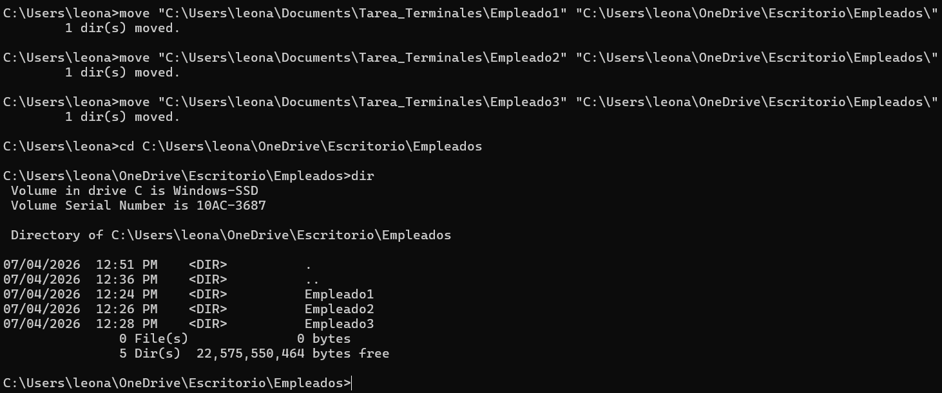
Ejercicio 4:
Comando:
C:\Users\leona\OneDrive\Escritorio\Empleados>dir
Volume in drive C is Windows-SSD
Volume Serial Number is 10AC-3687

Directory of C:\Users\leona\OneDrive\Escritorio\Empleados

07/04/2026 12:51 PM <DIR> .
07/04/2026 12:36 PM <DIR> ..
07/04/2026 12:24 PM <DIR> Empleado1
07/04/2026 12:26 PM <DIR> Empleado2
07/04/2026 12:28 PM <DIR> Empleado3
0 File(s) 0 bytes
5 Dir(s) 22,570,659,840 bytes free
Imagen:
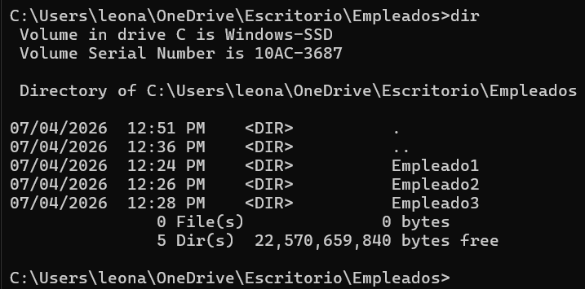
Ejercicio 5:
Comando:
C:\Users\leona\OneDrive\Escritorio\Empleados> ping Google.com

Pinging google.com [192.178.50.46] with 32 bytes of data:
Reply from 192.178.50.46: bytes=32 time=47ms TTL=248
Reply from 192.178.50.46: bytes=32 time=47ms TTL=248
Reply from 192.178.50.46: bytes=32 time=48ms TTL=248
Reply from 192.178.50.46: bytes=32 time=47ms TTL=248

Ping statistics for 192.178.50.46:
Packets: Sent = 4, Received = 4, Lost = 0 (0% loss),
Approximate round trip times in milli-seconds:
Minimum = 47ms, Maximum = 48ms, Average = 47ms

C:\Users\leona\OneDrive\Escritorio\Empleados>
Imagen:
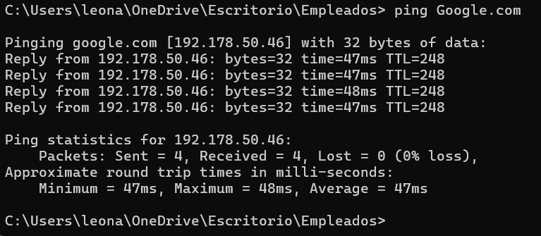
Ejercicio #6:
Comando:
C:\Users\leona\OneDrive\Escritorio\Empleados>tasklist
RuntimeBroker.exe 46444 Console 23 26,972 K
CalculatorApp.exe 35464 Console 23 89,432 K
RuntimeBroker.exe 2232 Console 23 26,508 K
tasklist.exe 38676 Console 23 11,812 K

C:\Users\leona\OneDrive\Escritorio\Empleados> taskkill /F /PID 35464
SUCCESS: The process with PID 35464 has been terminated.

C:\Users\leona\OneDrive\Escritorio\Empleados>
Imagen:
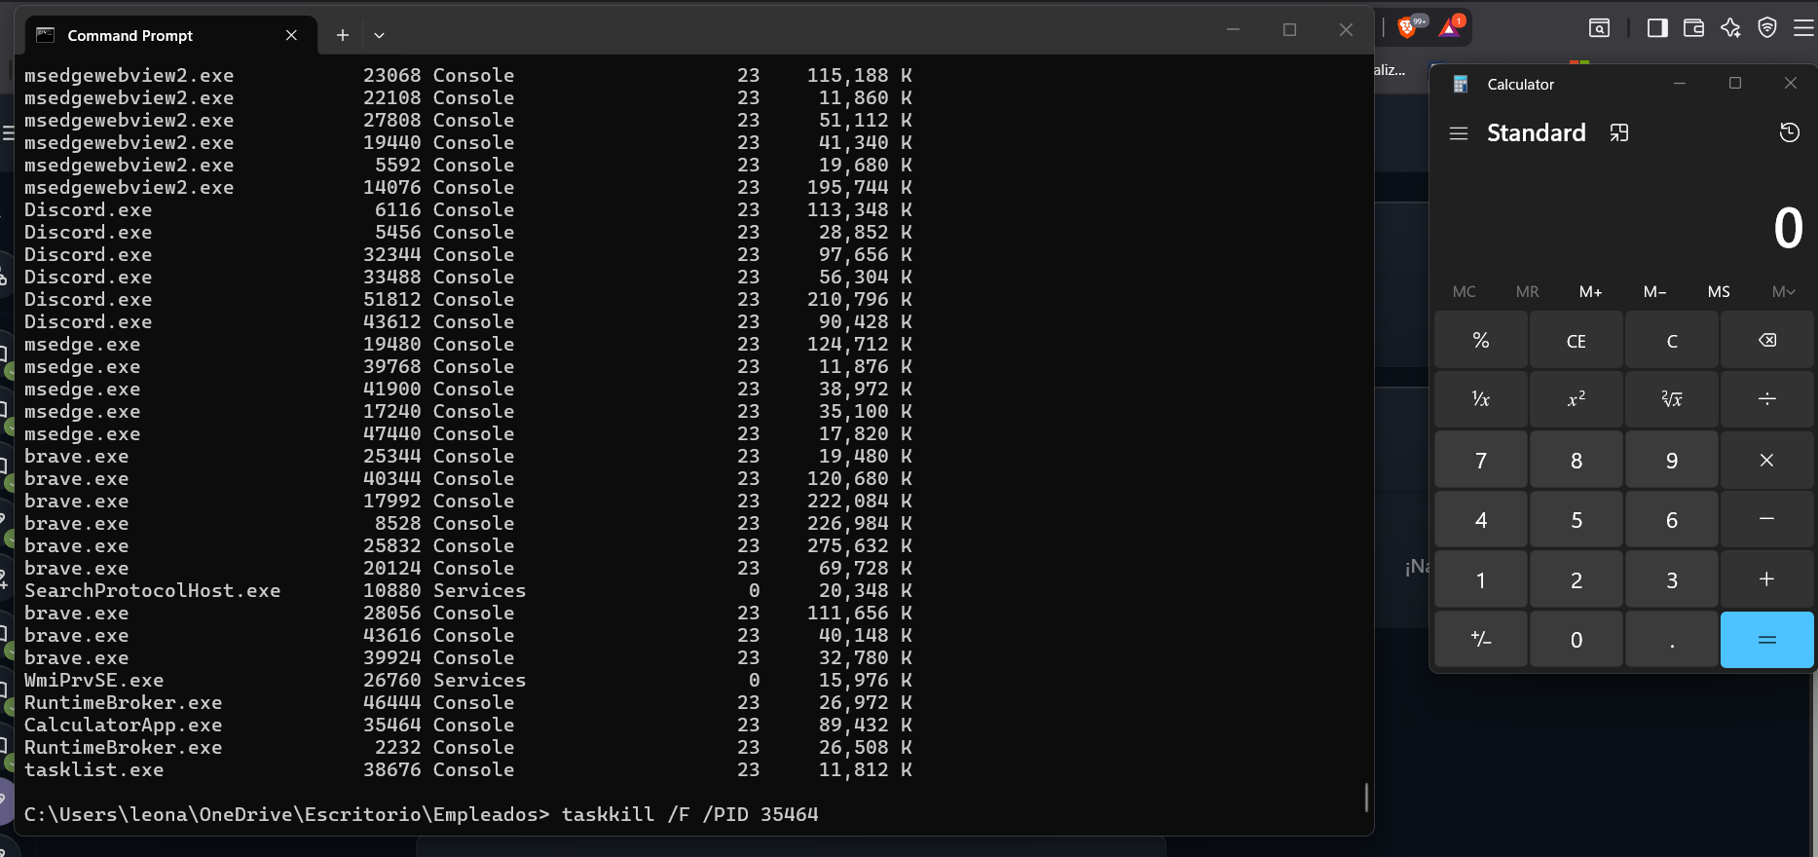
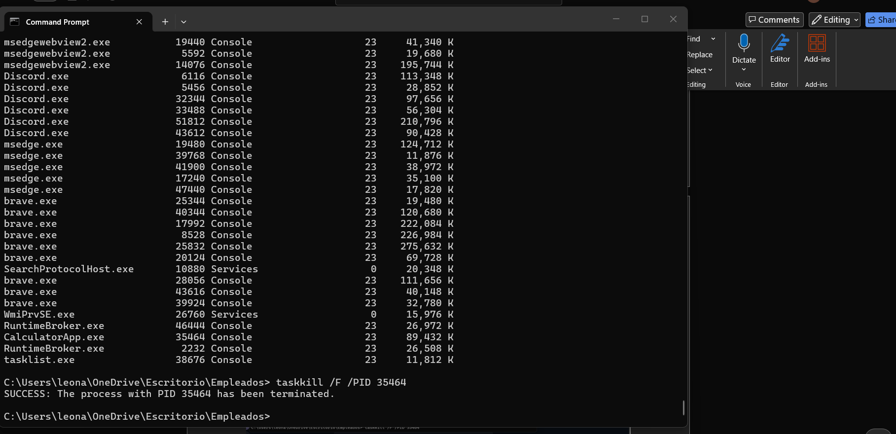
Ejercicio 7:
Comando:
C:\Users\leona\OneDrive\Escritorio\Empleados>time /t
01:15 PM

C:\Users\leona\OneDrive\Escritorio\Empleados>
Imagen:
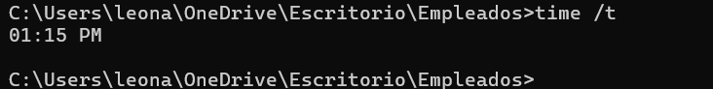
Ejercicio 8:
Comando:
C:\Users\leona\OneDrive\Escritorio\Empleados>rename welcome.txt welcome1.txt

C:\Users\leona\OneDrive\Escritorio\Empleados>rename Empleado2 welcome2.txt

C:\Users\leona\OneDrive\Escritorio\Empleados>rename Empleado3 welcome3.txt

C:\Users\leona\OneDrive\Escritorio\Empleados>dir
Volume in drive C is Windows-SSD
Volume Serial Number is 10AC-3687

Directory of C:\Users\leona\OneDrive\Escritorio\Empleados

07/04/2026 01:20 PM <DIR> .
07/04/2026 12:36 PM <DIR> ..
07/04/2026 12:24 PM <DIR> welcome1.txt
07/04/2026 12:26 PM <DIR> welcome2.txt
07/04/2026 12:28 PM <DIR> welcome3.txt
0 File(s) 0 bytes
5 Dir(s) 22,531,846,144 bytes free

C:\Users\leona\OneDrive\Escritorio\Empleados>
Imagen:
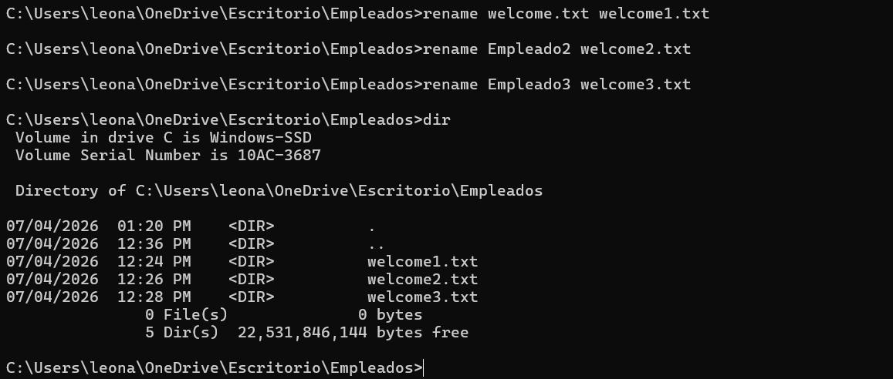
Ejercicio #9:
Comando:
C:\Users\leona\OneDrive\Escritorio>rd /s /q Empleados

C:\Users\leona\OneDrive\Escritorio>dir
Volume in drive C is Windows-SSD
Volume Serial Number is 10AC-3687

Directory of C:\Users\leona\OneDrive\Escritorio

07/04/2026 01:26 PM <DIR> .
06/25/2026 09:04 AM <DIR> ..
12/24/2025 04:03 PM 2,049 ASIO4ALL Web Site.lnk
12/26/2025 12:44 PM 6,507 certificado.pfx
09/18/2023 06:57 PM 1,105 Cisco Packet Tracer.lnk
05/25/2011 12:25 AM 2,541,180 ConstructorVirtualDeCircuitos.exe
07/04/2026 12:25 PM 2,440 Discord.lnk
03/11/2024 12:24 PM 1,111 Eclipse IDE for Java Developers - 2023-12 - Copy.lnk
03/11/2024 12:24 PM 1,111 Eclipse IDE for Java Developers - 2023-12.lnk
07/02/2025 12:03 PM 2,388 GitHub Desktop.lnk
03/13/2025 10:10 AM 1,436 Grammarly.lnk
11/26/2023 10:47 PM <DIR> Grupo #2 estructuras
03/20/2020 08:38 PM 9,142,272 hamachi.msi
02/25/2026 03:59 PM 2,369 Microsoft Edge.lnk
02/10/2022 08:39 PM 31,461,240 MinecraftInstaller (1) - Copy.exe
02/10/2022 08:39 PM 31,461,240 MinecraftInstaller (1).exe
02/19/2025 07:23 PM 2,206 Postman.lnk
11/25/2023 04:41 PM 32,478 ProyectoAvance1_Grupo2Lista.zip
06/19/2025 08:43 PM 36,150 Removed Apps.html
03/13/2025 01:00 PM 1,547 Shortcut to Desktop (OneDrive - Personal) - Copy.lnk
03/13/2025 12:58 PM 1,547 Shortcut to Desktop (OneDrive - Personal).lnk
06/24/2025 12:26 PM 1,867 Spotify.lnk
05/28/2024 11:58 AM 1,526 sqldeveloper - Shortcut.lnk
07/24/2025 05:36 PM 797 Swift for Windows.lnk
07/30/2025 10:02 AM 1,421 Visual Studio Code.lnk
03/09/2022 08:06 AM 2,218 WhatsApp.lnk
06/26/2026 08:53 AM 1,968 Zoom Workplace.lnk
24 File(s) 74,710,173 bytes
3 Dir(s) 21,719,375,872 bytes free

C:\Users\leona\OneDrive\Escritorio>cd empleados
The system cannot find the path specified.

C:\Users\leona\OneDrive\Escritorio>
Imagen:
